
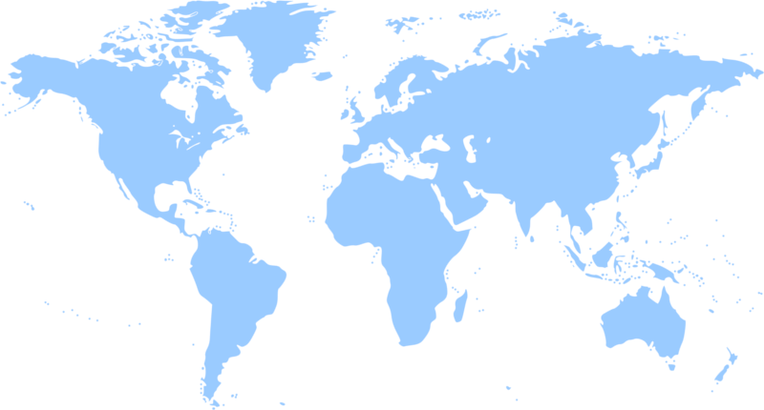
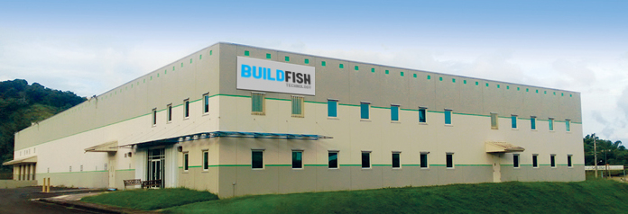
PROFORMA INVOICE
o.partner_id.display_name
bf_number
o.bf_date_invoice

Customer: | : o.partner_id.display_name
Dear: | :
Address: | : o.partner_id.bf_street
E-Mail: | : o.partner_id.bf_email
Phone: | : o.partner_id.bf_phone | Fax | :
Subject: | :

No | Description | Unit Price | Qty. | Total Price
for="line_count, line in enumerate(o.invoice_line_ids, 1)"
i | name  bf_name | bf_price_unit | qty | bf_price_subtotal
/for
Subtotal: |  |  |  | bf_amount_untaxed
Taxes: |  |  |  | bf_amount_tax
Total: |  |  |  | bf_amount_total

ERECTION
BUILDFISH EXPORT will provide a superviser during the erection works. The customer will provide
lifting equipment, elecricity, water, welding equipment and skilled labour during erection.The
operators of the customer will be work on the operation and maintenance of the plant during
erection and start-up. The customer will provide local accommodation and local transportation for
the technicians of BUILDFISH EXPORT. the customer will prepare the base concretes according to
the concrete plans given by BUILDFISH EXPORT. The start-up of the plant will be made by
BUILDFISH EXPORT’s technicians. If the erection duration exceeds 15 days except BUILDFISH
EXPORT’s fault, the customer will pay 200 USD ( $ ) / 150 EURO ( € ) day per each tehnician.

MANUFACTURER
BUILD MANA . SAN. TIC. D.A.S.

GUARANTEE
The equipments is under the guarantee of BUILDFISH EXPORT within a period of 12 month from
erection or 16 months the date of transportation documents which one comes first. BUILDFISH
EXPORT undertakes to raplece or repair free of cost, any part supplied by them, to be defective in
workmannship or materials providing that the defect has not been ceused by carelessness or
improper treatment, or inadequate lubriation or neglegt of proper adjustment, or by any omission to
comply with any instruction given by BUILDFISH EXPORT. Wearing parts is not included in the
guarantee.

DELIVERY
CDFR / ALRGER. The machines will be loaded in 60 days after receiving the confirmation of L/C.

PAYMENT
Irrevocable and comfirmed letter of credit for 100% of the total price to be opened simultaneously
with the purchase order in favour of BUILDFISH EXPORT MAKINE A.S. to expire 21 days after last
date of shipment. The L/C must be confirmed and payable by our bank as %100 upon presentation
of shipment documents. All charges inside and outside Turkey are for applicant's account.

BENEFICIARY
BUILDFISH EXPORT MAKINE A.S.

BANK
ZİRAAT BANKASI
SWİFT KODU: TCZBTR2AXXX
TR13000100192989694234235 USD
TR83000123423523523523324 EUR

OFFER VALIDITY
This offer valid for 30 days.

